Greggs plc: Designing the Next Step of a Digital Transformation
Mid-term note – The Strategy of Digital Transformation
Student number: [insert] Date: 30 October 2026

Introduction
Greggs is the UK’s largest food-to-go retailer, with 2,739 shops and sales of £2,151 million in 2025 (Greggs plc, 2026). Its success rests on a simple promise: decent food at low prices, close to where people live, work and travel. Greggs is not a digital laggard. Its app is scanned in 26.7% of company-managed shop transactions, up from 20.1% a year earlier, and delivery makes up 6.8% of sales (Greggs plc, 2026). The same results, however, show sales rising by 6.8% while underlying operating profit fell by 4.0%. Growth is no longer turning into margin. This note argues that the next step is to turn the app from a loyalty card into the engine of a data-driven production and pricing system, and it sets out how Greggs could organise itself for that change.

1. Value opportunities
Following the course logic of moving from macro-level trends to industry-level change (Aguilar, 1967; Porter, 2008), three trends matter most for Greggs.
Economic. Costs are rising faster than prices can follow. The increase in employer National Insurance to 15% from April 2025 (HM Treasury, 2024) falls heavily on a labour-intensive shop estate, while consumers under pressure are trading down. At industry level, this sharpens rivalry with supermarket meal deals, and buyers face almost no switching costs. For a firm whose margin depends on volume and tight cost control, this is a direct threat.
Social. Eating is becoming more mobile and spread more evenly across the day. Evening is Greggs’ fastest-growing daypart, at 9.4% of sales (Greggs plc, 2026), and customers increasingly expect to order on a phone. At industry level, delivery aggregators such as Just Eat and Uber Eats have gained bargaining power: they own the customer interface and take a commission on every order.
Environmental. Fresh bakery leaves unsold food every evening. Greggs already passes surplus to Too Good To Go and has saved more than five million meals this way (Grocery Gazette, 2025), but this recovers waste rather than preventing it.
Together, these trends put pressure on an advantage built on low unit costs. They also point to an opportunity. Greggs owns a large stream of first-party customer data through its app, and it controls its own manufacturing and logistics. Few rivals have both.

2. How the business model will change
Figure 2 contrasts the current and proposed business models using the value creation, value configuration and value capture framework (Whittington et al., 2024). Today, Greggs creates value through affordable, consistent food available almost everywhere (C1). Its configuration is vertically integrated, with central bakeries supplying shops, but daily bake quantities are still largely set shop by shop (C2). Value is captured through high volume, low prices and the same stamp-based rewards for every customer (C3).
Three value gaps follow. First, the app collects data but gives little back beyond a stamp card. [PRIMARY OBSERVATION – replace this sentence with one or two sentences describing what your own Figure 1 shows, e.g. what the Greggs App home and rewards screens offered you on a given day, or what you observed on the shelves of a named Greggs shop near closing time.] Second, production is not linked to live demand signals, so surplus is sold off at a fraction of its price. Third, delivery orders run through aggregators that keep part of the margin and most of the customer data.
[INSERT YOUR OWN PRIMARY OBSERVATION HERE – e.g. a dated screenshot of the Greggs App rewards/home screen, a photo of a Greggs shop counter near closing time, or a short quote from a Greggs customer or employee. Delete this instruction once inserted.]

Figure 1: Primary observation of the current value gap (author’s own, [date])
The proposed model, called here ‘Greggs Connected’, closes these gaps. Customers receive personalised offers and can order ahead into collection slots, including in the evening (P1). An AI demand-forecasting layer combines app pre-orders, sales history, weather and local events to produce shop-level bake plans and to inform central production at the new distribution sites (P2). Value is captured through more frequent visits and larger baskets, lower waste and labour costs, in-app late-day discounts before surplus reaches Too Good To Go, and a gradual shift of orders from aggregators to Greggs’ own app (P3). Because shop managers can correct the forecast, their local knowledge feeds back into the model and improves it over time (P4).
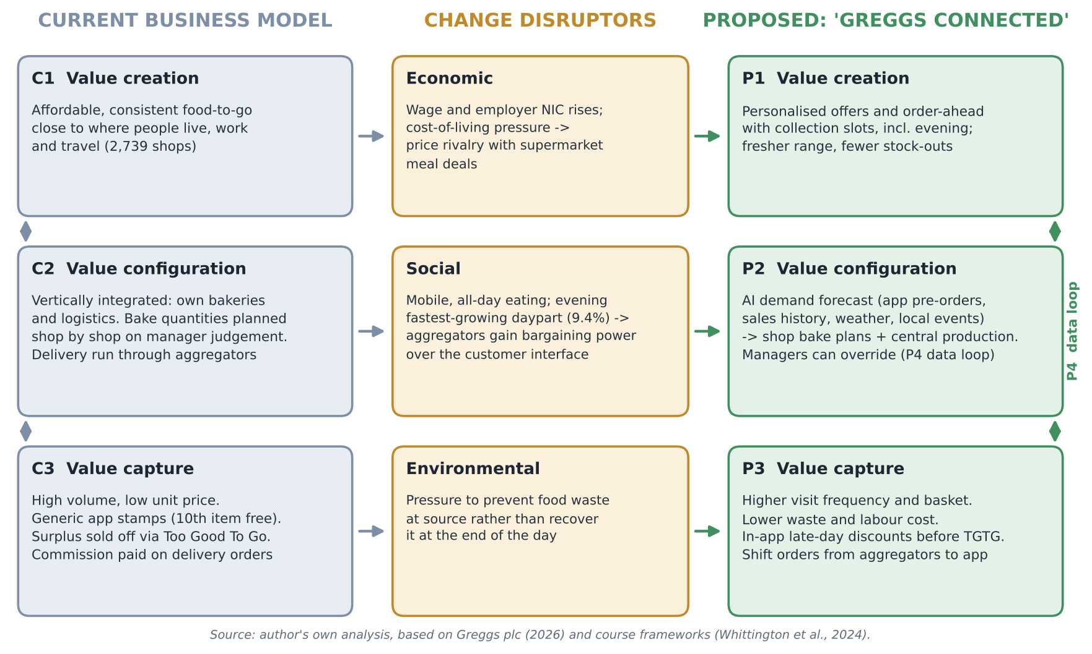
Figure 2: Current versus proposed Greggs business model (author’s own)

3. The suggested competitive advantage
Greggs competes on the same critical success factors as its rivals (price, convenience and taste) rather than creating new ones, so the relevant logic is that of generic strategies rather than a blue ocean (Kim and Mauborgne, 2004). Its position is best described as hybrid: cost leadership combined with enough differentiation, through brand and signature products, to earn loyalty (Whittington et al., 2024). The transformation aims to reinforce both sides. Better forecasting lowers unit costs through less waste and tighter staffing, while personalisation raises revenue per customer. One caveat is important. An app on its own is easy to copy, and Tesco’s Clubcard is far ahead on customer data. What rivals cannot easily copy is the link between Greggs’ customer data and its own vertically integrated supply chain. The advantage therefore lies in the fit between activities, not in any single technology (Porter, 1996).

4. Potential challenges to change
Most digital transformations fall short for organisational rather than technical reasons (de la Boutetière, Montagner and Reich, 2018). Three challenges stand out for Greggs.
The first is a competency trap. Greggs’ core capability is operational efficiency built on standard products, standard processes and central control. After a run of record sales, it is easy to ask why anything should change, and that capability can become a core rigidity (Leonard-Barton, 1992).
The second concerns the bounded rationality of leaders. Managers may read digital as a marketing channel, measured in app downloads, rather than as a change to the operating model. With capital expenditure peaking at £287.5 million in 2025 and profit guided to stay flat in 2026 (Greggs plc, 2026), there is strong pressure to postpone projects without a quick payback.
The third is resistance on the shop floor. Shop managers who have always judged their own bake may see an algorithm as a threat to their autonomy. Most staff work in shops rather than at desks, so they are hard to reach through conventional corporate channels. The 602 franchised units add partners whose incentives differ from Greggs’ own.

5. Overcoming the challenges
Greggs should run the change as a dual strategy. A small ‘Greggs Connected’ unit, protected from short-term cost targets and reporting directly to the executive team, would explore the new model while core operations continue to exploit the current one (O’Reilly and Tushman, 2004). Building dynamic capabilities means turning this into a routine: sense opportunities, test them in a pilot of around 50 shops in one region, measure the results for waste, sales and staff, and reconfigure resources before scaling (Teece, 2007).
Greggs does not need to become Google. A moderate target level of agility is enough, concentrated where data, supply chain and shops meet (Rigby, Sutherland and Noble, 2018). Of the eight dimensions of the agile model covered in class (Curchod, 2026a), three are most relevant:
- Processes and routines: a cross-functional team drawn from data, supply chain, shop operations, marketing and two serving shop managers, working in short cycles and with the authority to change bake-plan rules.
- Skills and employee development: data specialists are recruited, and shop managers are trained to read forecasts and to override them. Presenting the algorithm as a recommendation rather than an instruction keeps ownership in the shop and reduces resistance.
- Communication and transparency: pilot results and shop-level waste savings are shared with staff through mobile channels, and feedback is collected in the same way.
Finally, the model must fit the UK’s Western digital ecosystem (Curchod, 2026b). Customers already use aggregators and mobile wallets, so the Greggs app should work alongside them rather than try to replace them.

Conclusion
Greggs has already built the pieces of a digital business: an app used in more than a quarter of transactions, delivery partnerships and new supply-chain capacity. The next step is to connect them, so that customer data shapes what is baked, where and when. Done in stages and with shop managers involved, this would protect Greggs’ hybrid advantage at a time when cost pressures are eroding it.
Word count: 1290 words (excluding title, figures, captions and reference list)

Reference list
Aguilar, F.J. (1967) Scanning the business environment. New York: Macmillan.
Collis, D. (2021) ‘Why do so many strategies fail?’, Harvard Business Review, 99(4). Available at: https://hbr.org/2021/07/why-do-so-many-strategies-fail (Accessed: 30 October 2026).
Curchod, C. (2026a) ‘Organizing for digital transformation: the agile organization’ [Lecture slides], The Strategy of Digital Transformation. University of Edinburgh Business School. Available at: Learn (Accessed: 30 October 2026).
Curchod, C. (2026b) ‘Beware national cultures: an exploration of the East vs. West digital ecosystems’ [Lecture slides], The Strategy of Digital Transformation. University of Edinburgh Business School. Available at: Learn (Accessed: 30 October 2026).
de la Boutetière, H., Montagner, A. and Reich, A. (2018) Unlocking success in digital transformations. McKinsey & Company. Available at: https://www.mckinsey.com/capabilities/people-and-organizational-performance/our-insights/unlocking-success-in-digital-transformations (Accessed: 30 October 2026).
Greggs plc (2026) Preliminary results for the 52 weeks ended 27 December 2025. Newcastle upon Tyne: Greggs plc. Available at: https://assets.greggs.com/f/162306/x/e616871d6c/260303-greggs-2025-preliminary-results-final.pdf (Accessed: 30 October 2026).
Grocery Gazette (2025) ‘Greggs saves 5m meals from waste with Too Good To Go’, 30 April. Available at: https://www.grocerygazette.co.uk/2025/04/30/greggs-too-good-to-go/ (Accessed: 30 October 2026).
HM Treasury (2024) Autumn Budget 2024 (HC 295). London: HM Treasury. Available at: https://www.gov.uk/government/publications/autumn-budget-2024 (Accessed: 30 October 2026).
Kim, W.C. and Mauborgne, R. (2004) ‘Blue ocean strategy’, Harvard Business Review, 82(10), pp. 76–84.
Leonard-Barton, D. (1992) ‘Core capabilities and core rigidities: a paradox in managing new product development’, Strategic Management Journal, 13(S1), pp. 111–125. doi: 10.1002/smj.4250131009.
O’Reilly, C.A. and Tushman, M.L. (2004) ‘The ambidextrous organization’, Harvard Business Review, 82(4), pp. 74–81.
Porter, M.E. (1996) ‘What is strategy?’, Harvard Business Review, 74(6), pp. 61–78.
Porter, M.E. (2008) ‘The five competitive forces that shape strategy’, Harvard Business Review, 86(1), pp. 78–93.
Rigby, D.K., Sutherland, J. and Noble, A. (2018) ‘Agile at scale’, Harvard Business Review, 96(3), pp. 88–96.
Teece, D.J. (2007) ‘Explicating dynamic capabilities: the nature and microfoundations of (sustainable) enterprise performance’, Strategic Management Journal, 28(13), pp. 1319–1350. doi: 10.1002/smj.640.
Whittington, R., Regnér, P., Angwin, D., Johnson, G. and Scholes, K. (2024) Fundamentals of strategy. 6th edn. Harlow: Pearson.

